Chapter 13, Solution 21.

Using Fig. 13.90, design a problem to help other students to better understand energy in a coupled circuit.

Although there are many ways to solve this problem, this is an example based on the same kind of problem asked in the third edition.

Problem

Find I₁ and I₂ in the circuit of Fig. 13.90. Calculate the power absorbed by the
4-Ω resistor.

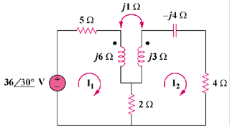

Figure 13.90

Solution

For mesh 1, 36∠30° = (7 + j6)I₁ – (2 + j)I₂ (1)

For mesh 2, 0 = (6 + j3 – j4)I₂ – 2I₁ – jI₁ = –(2 + j)I₁ + (6 – j)I₂ (2)

Placing (1) and (2) into matrix form, 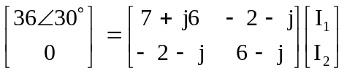

Δ = 45 + j25 = 51.48∠29.05°, Δ₁ = (6 – j)36∠30° = 219∠20.54°

Δ₂ = (2 + j)36∠30° = 80.5∠56.57°, I₁ = Δ₁/Δ = 4.254∠–8.51° A , I₂ = Δ₂/Δ = 1.5637∠27.52° A

Power absorbed by the 4-ohm resistor,

= 0.5(I₂)²4 = 2(1.5637)² = 4.89 watts

